Photo: CCTV camera

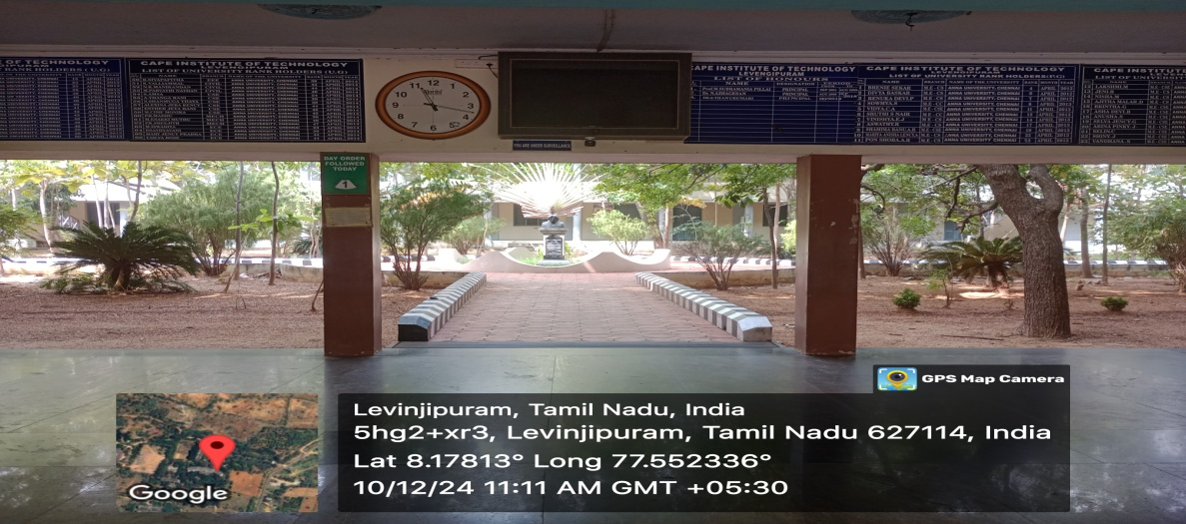

Photo: Notice board Facilities in Campus

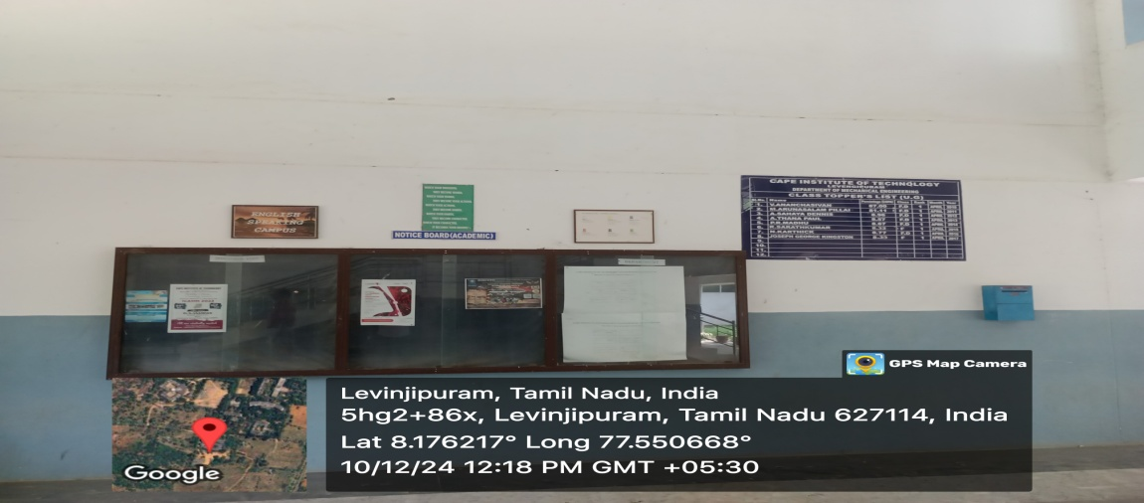

Photo: Internet Room

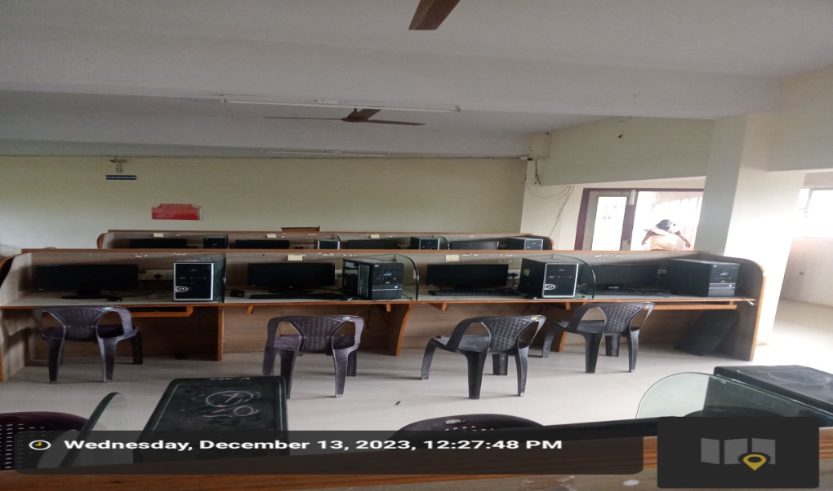

Photo: Common Reading Room Facilities Ladies Hostel

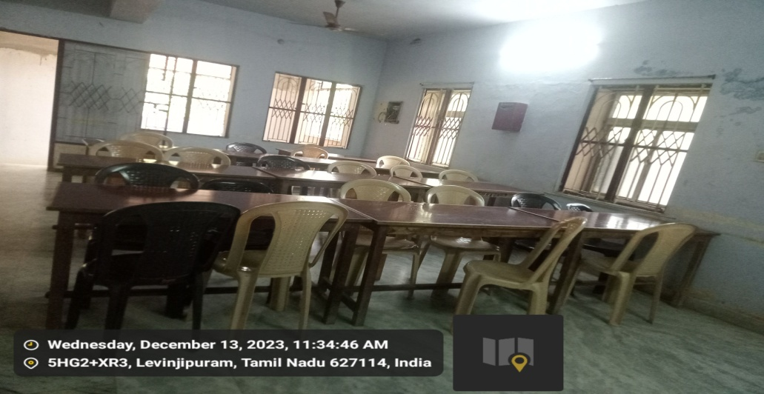

Photo: Visitor Room in Ladies Hostel
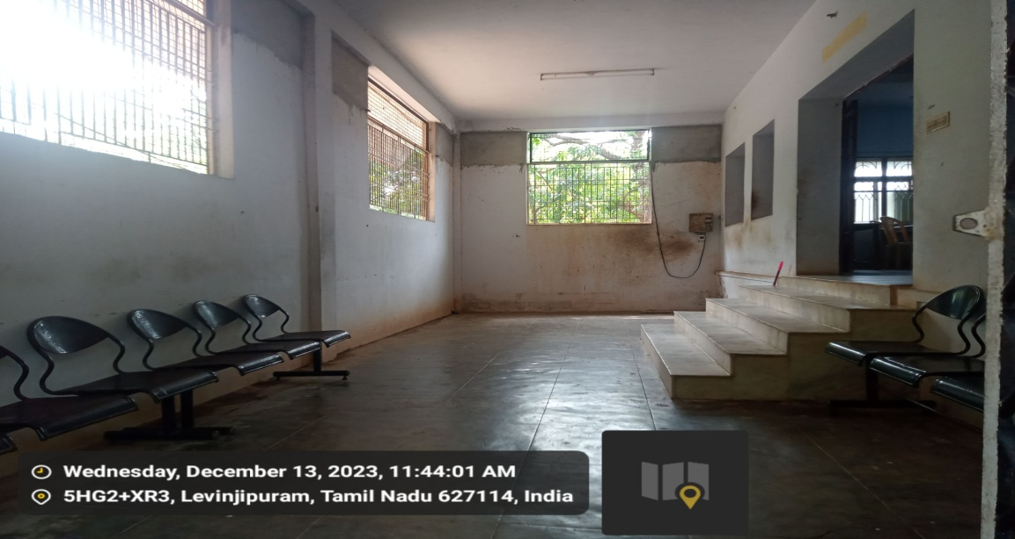

Photo: Gym Facilities Hostel
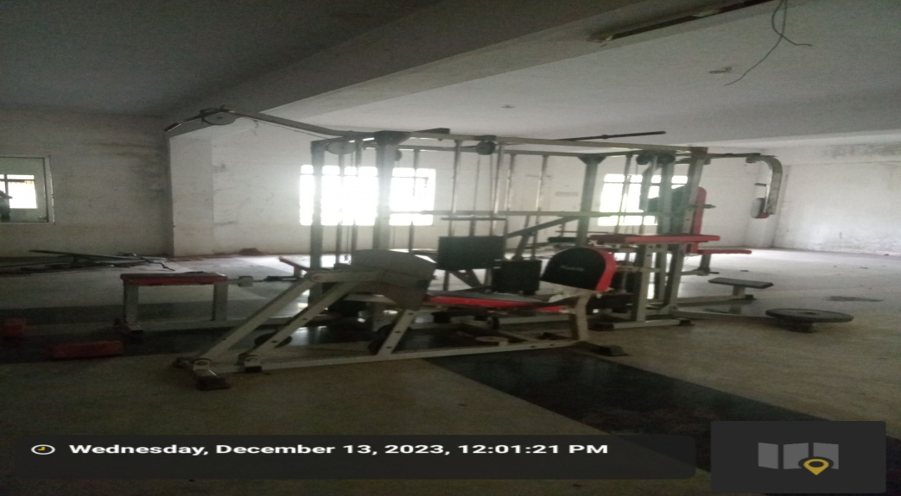

Photo: Security Facilities in Campus
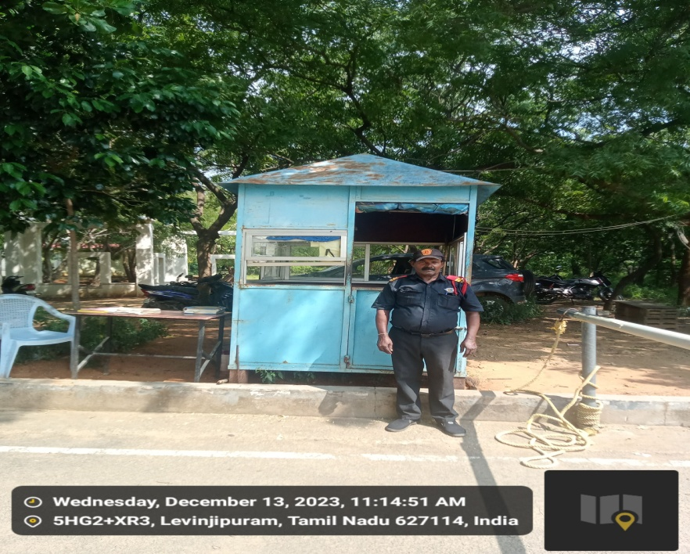

Photo: Visitor Register
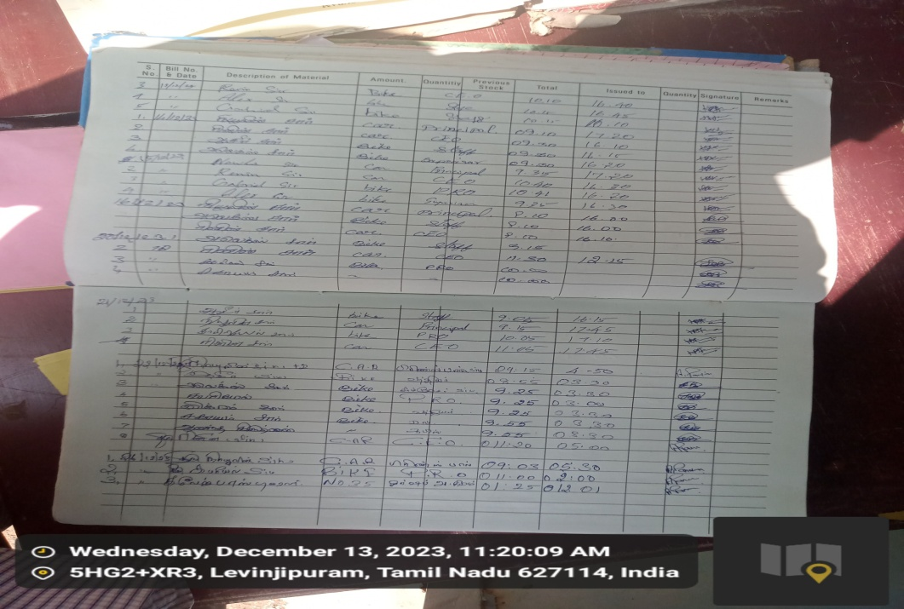

Photo: Visitor Card
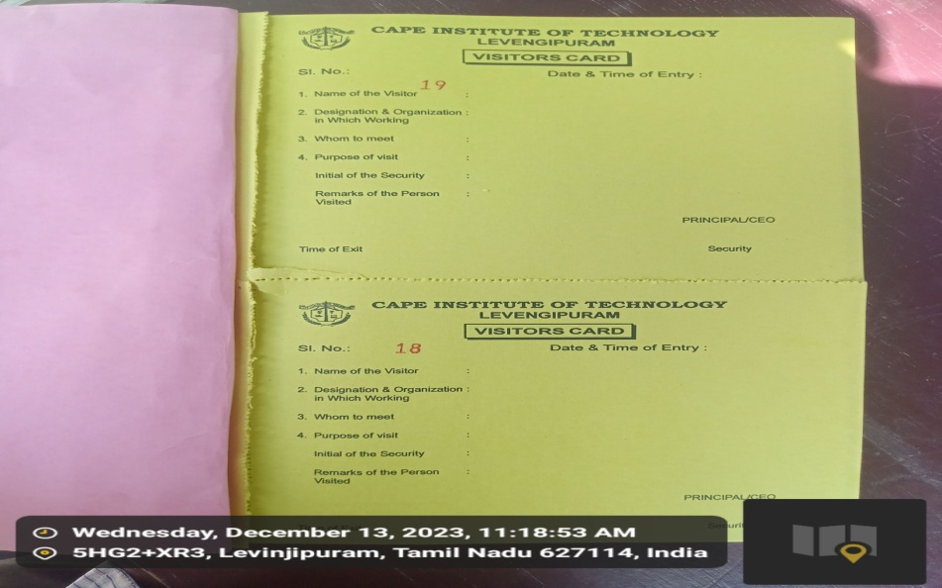

Photo: Library in Campus

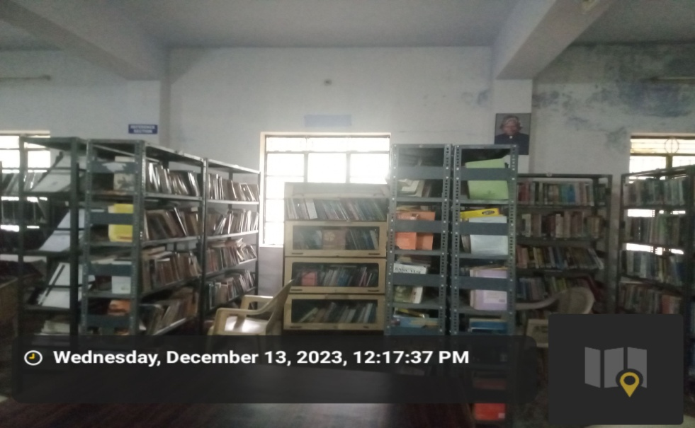

Photo: Medicine Facilities in Campus

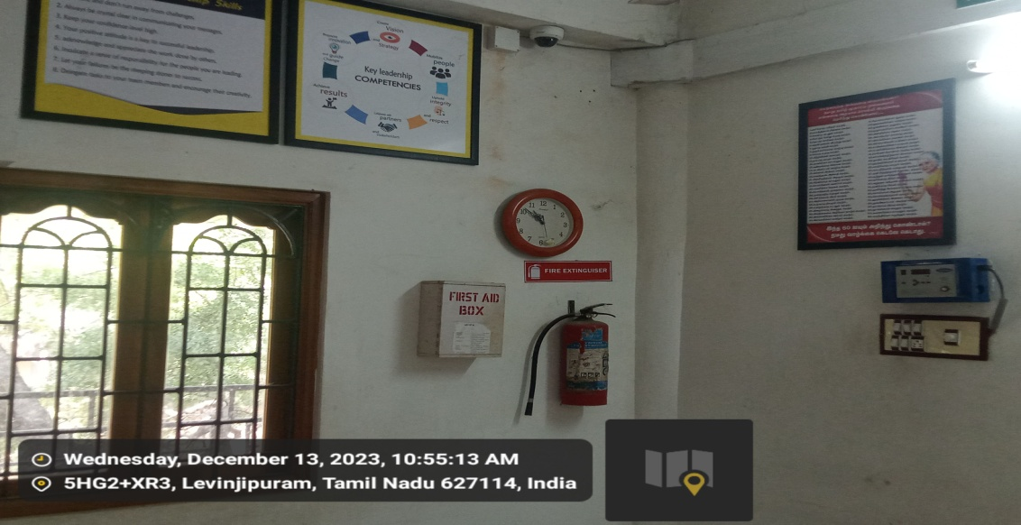

Photo: Suggestion Box Facilities in Campus

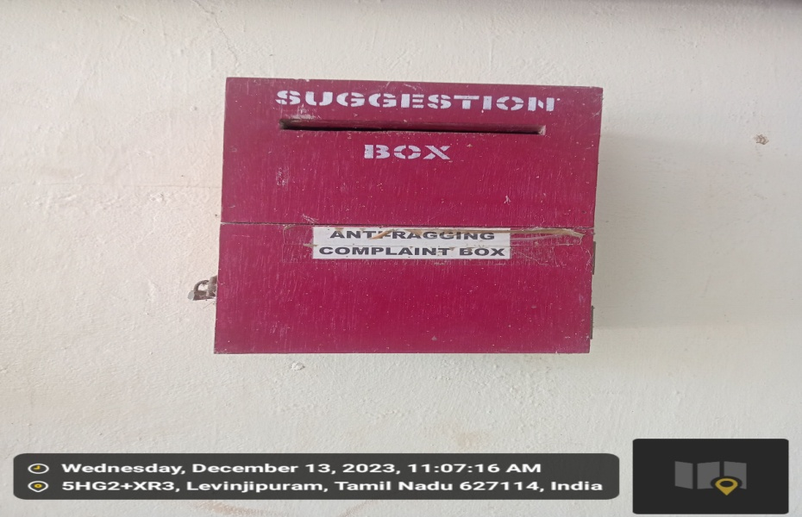

Photo: Record of entry of visitors at main gate

