SKILL DEVELOPMENT CENTRE

CAPE INSTITUTE OF TECHNLOGY
Skill Development Centre
Learning is the most essential tool to enhance the socio-economic growth of not only an individual but also of the entire nation. The higher education of 21st century faces several challenges in providing skill-centric learning, meeting the needs of the industry and society in the global platform. To confront such challenges, Cape Institute of Technology has established Centre for Skill Development, which aims to upgrade skills to international standards through significant industry participation and develop necessary frameworks of standards for quality assurance. Along with the outstanding academic learning, students in our institution are practically oriented with the different skill sets, bridging the gap between the academics and the industrial, societal needs.
Objectives of the Skill Development Centre:
- To conduct various skill development programmes to students and improve their employability.
- To promote entrepreneurship
- To contribute to the Manpower Development of our Nation and to elevate the standards of youth socially and economically.
- To endorse the knowledge exchange programmes.
- To facilitate the industrial institutional interactions.

The skill development centre of Cape Institute of Technology conducts various skill oriented programs like AI Programming, Machine learning, Cyber security, Internet of Things, Embedded Programming, Data Acquisition. Beyond the institutional focus, the skill Development Centre also extends its responsibility to the general public by conducting the training programmes to the rural youth in occupations like welding, Electrician, Plumbing, Lab Technician. In addition to that, having our institution known for its endless support for women empowerment, the centre also conducts exclusive Skill Development Courses like Beautician training, Baking and Tailoring for underprivileged and rural women.

Skill Development Activities
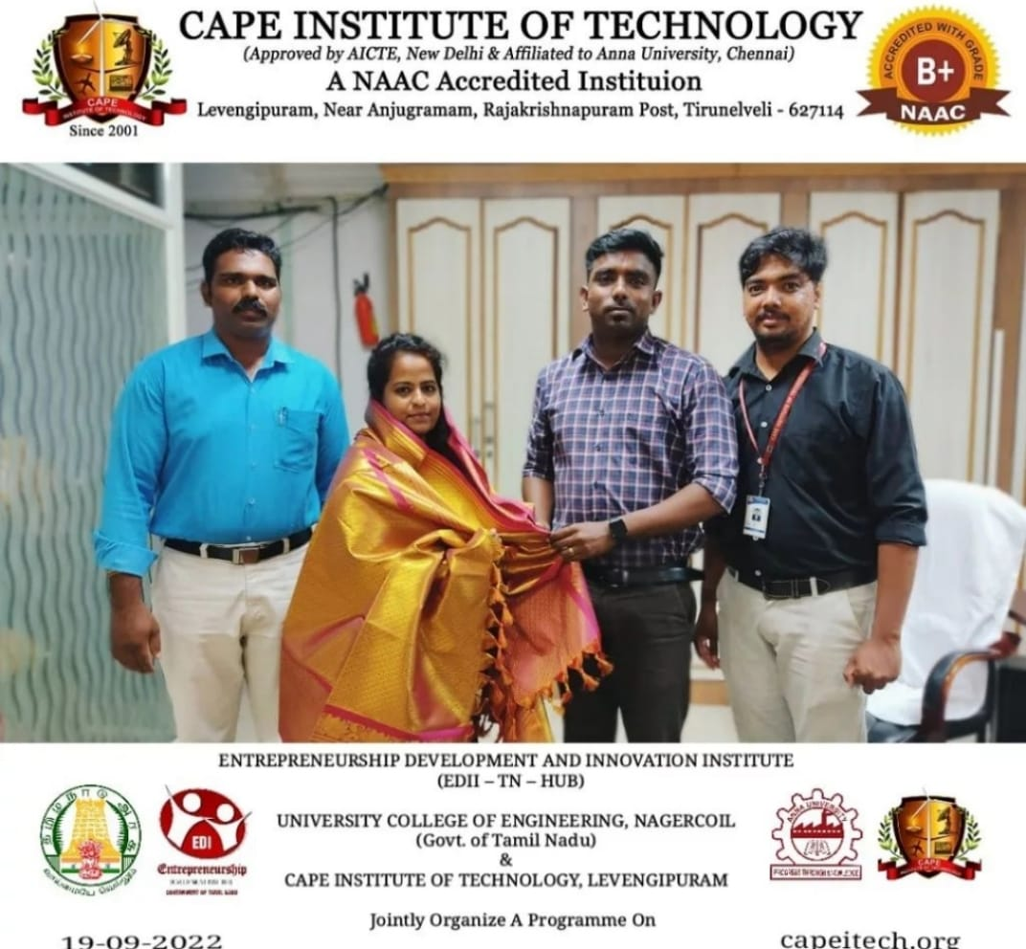
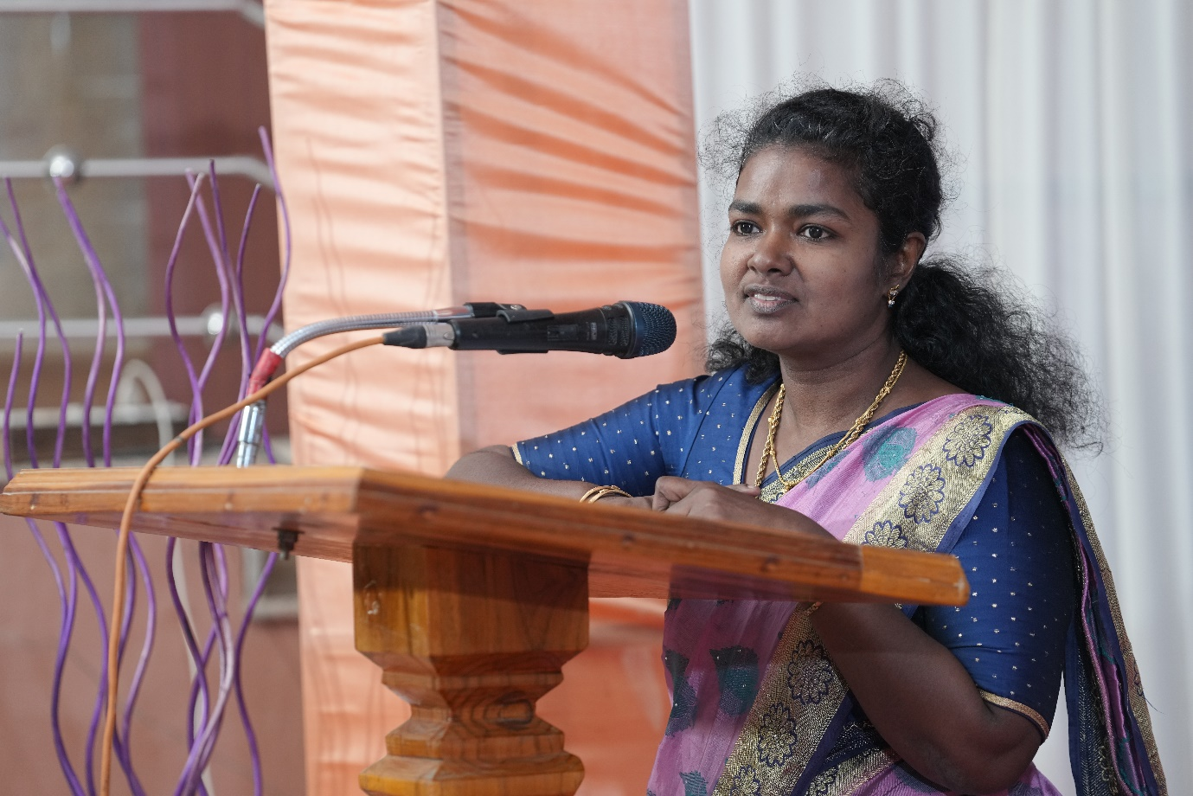
Mrs. Jerina Bubby (Assistant Director Branch MSME) DFO Tirunelveli addressing our students.
