**Photo: CCTV camera**

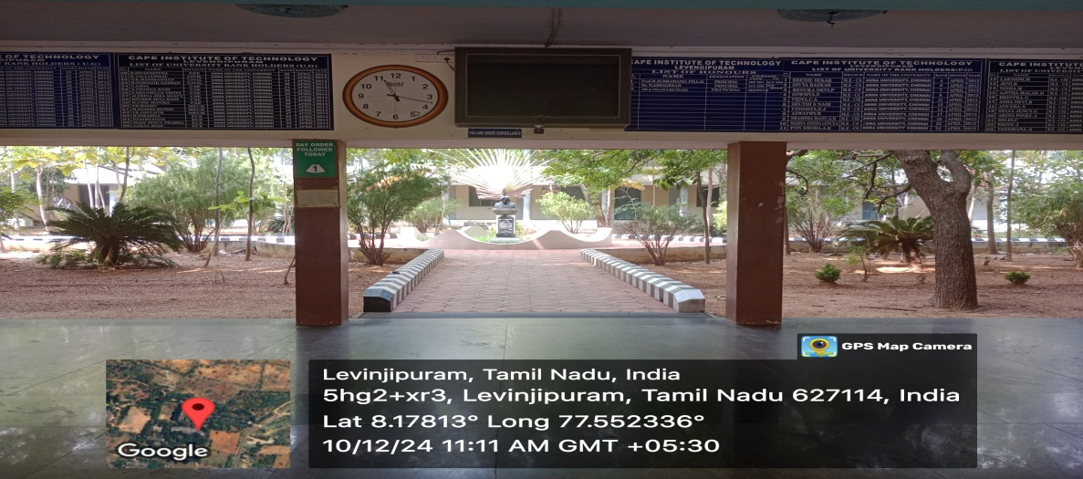

**Photo: Notice board Facilities in Campus**

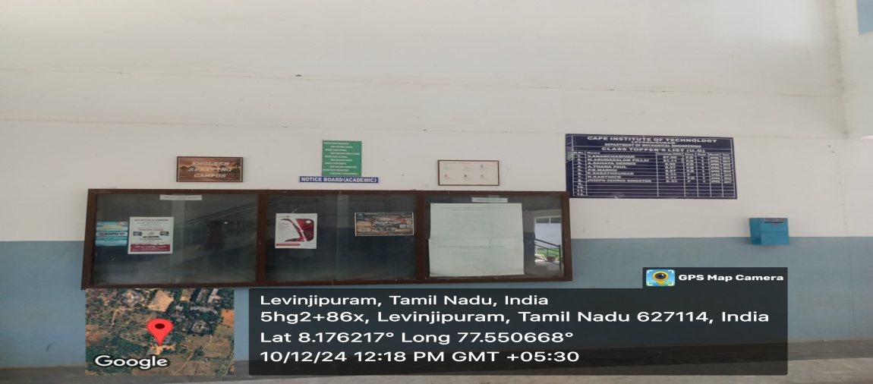

**Photo: Internet Room**

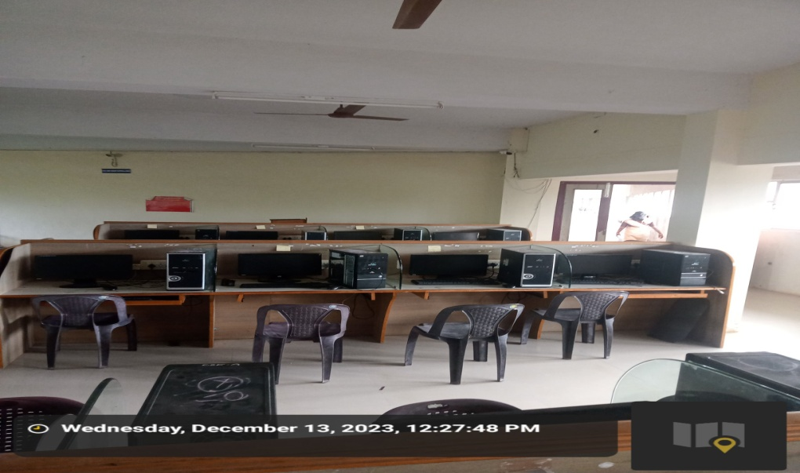

**Photo: Common Reading Room Facilities Ladies Hostel**

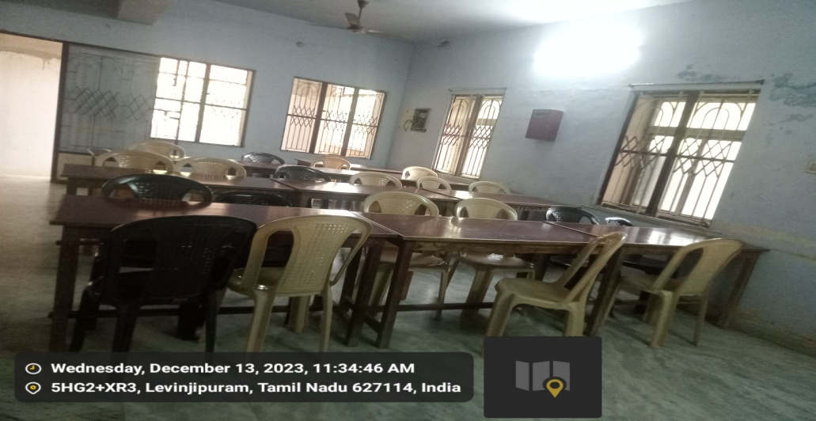

**Photo: Visitor Room in Ladies Hostel**

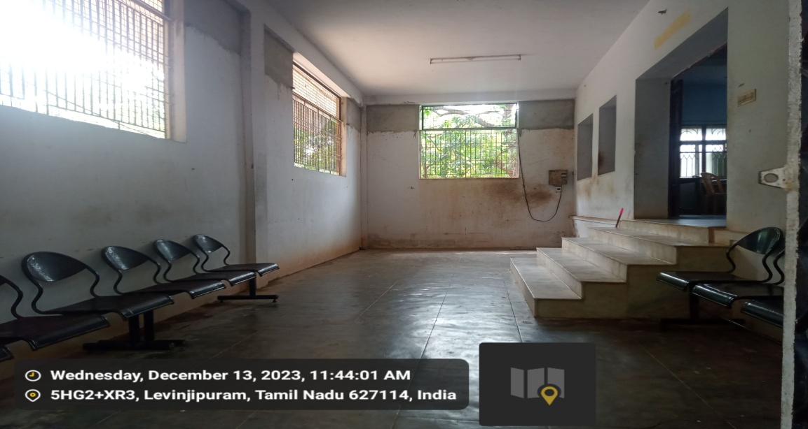

**Photo: Gym Facilities Hostel**

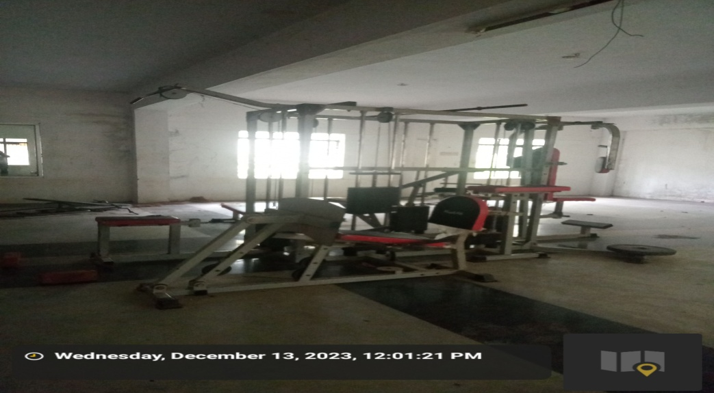

**Photo: Security Facilities in Campus**

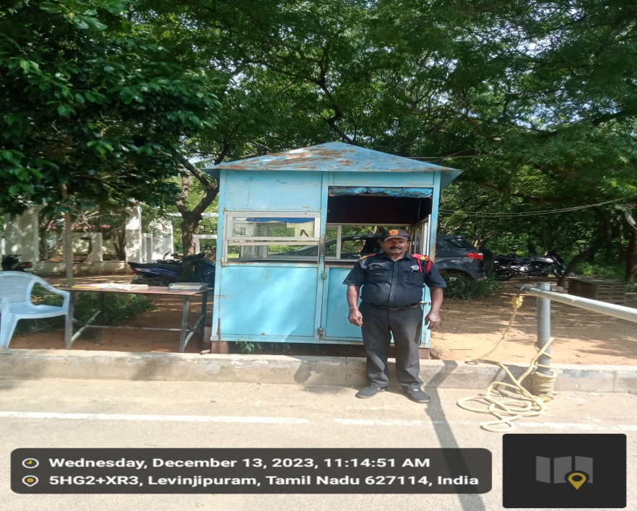

**Photo: Visitor Register**

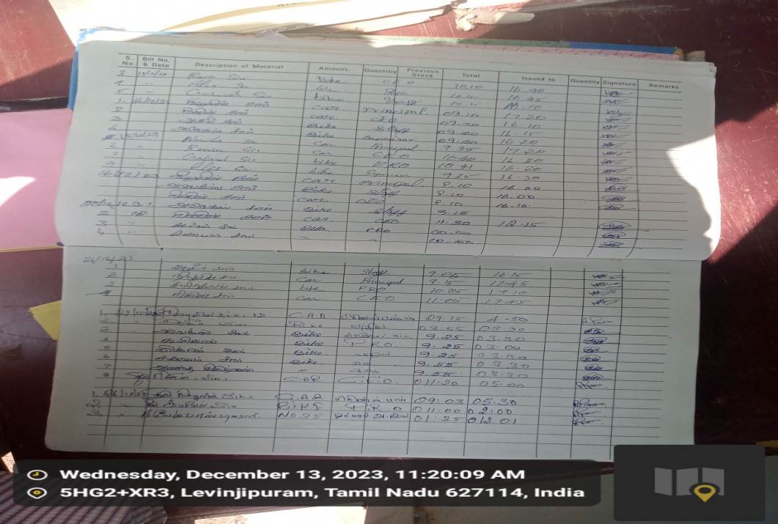

**Photo: Visitor Card**

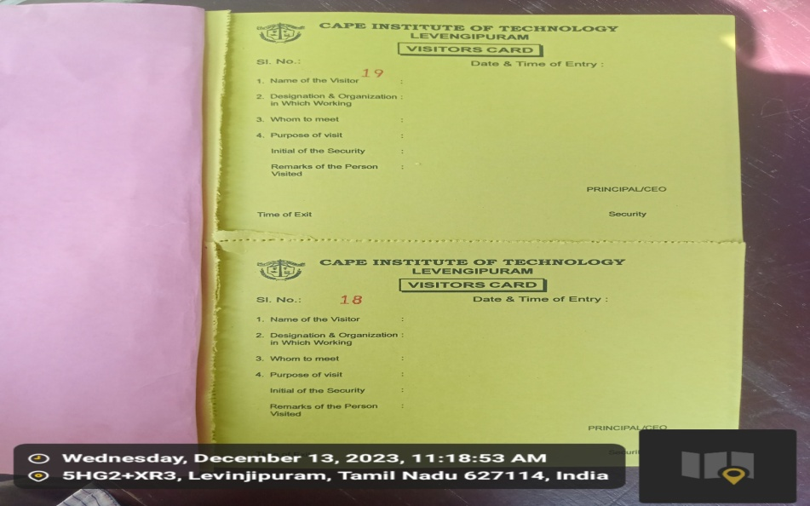

**Photo: Library in Campus**

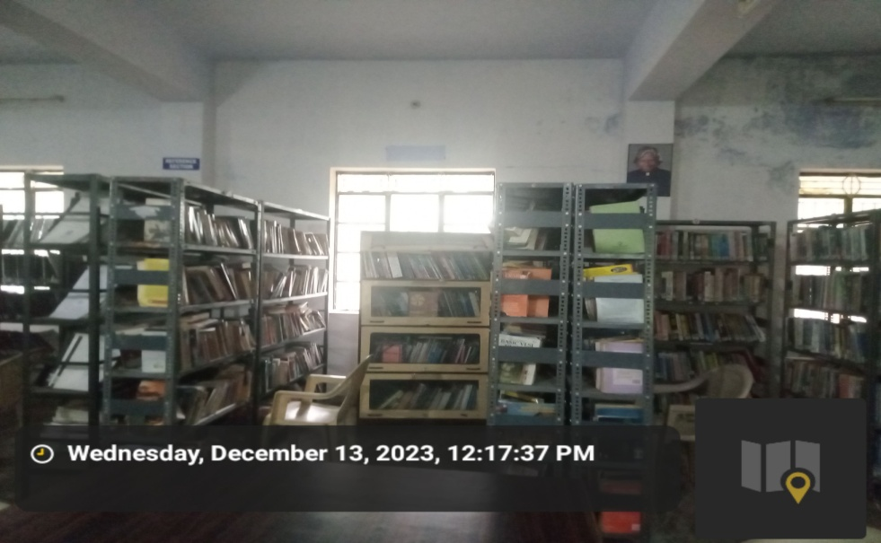

**Photo: Medicine Facilities in Campus**

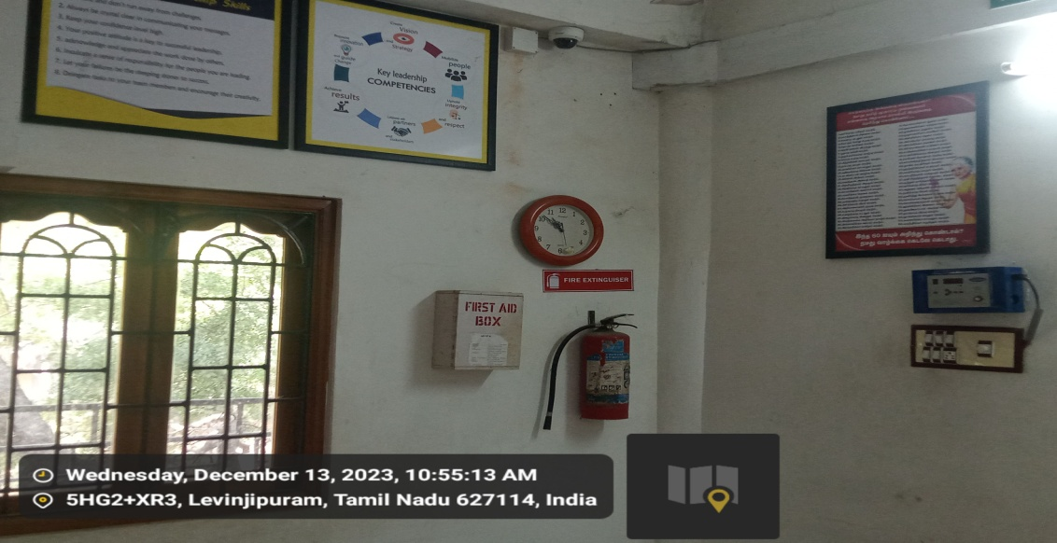

**Photo: Suggestion Box Facilities in Campus**

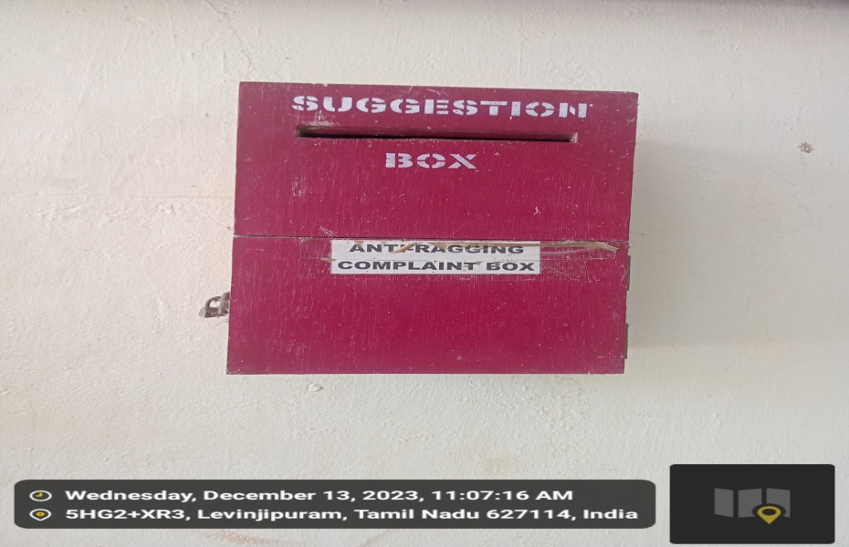

**Photo: Record of entry of visitors at main gate**

