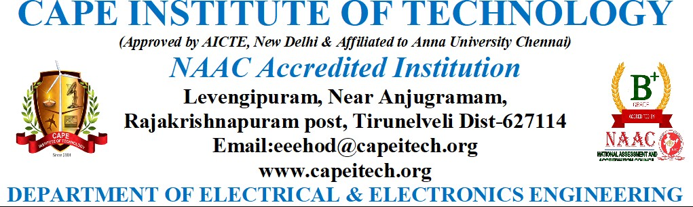

**7.2.1 - Describe two best practices successfully implemented by the Institution as per NAAC format provided in the Manual.**

**Objective:**

Monitoring academic exams and producing reports relating to them are the goals.

**Context:**

**The Practice:**

In conjunction with faculty members and the trust's executive body, management guides the institution toward a specific degree of excellence. Decentralization of authorities has been explicitly stated to every member of staff. Responsibilities are shared at different levels.

The process of planning, carrying out, monitoring, reporting, and taking appropriate action for various duties at the academic level and for the general development of the students is started by the Principal and the HODs. Without a campus management entry system, the instructors must manually compile each report. The procedure takes a lot of time, and different departments use different documentation formats.

The following functions are carried out:

* Students create unique logins by entering their personal information
* Faculty members log in and enter information about internal assessments
* Each employee has a unique username and password for logging in.
* Department heads submit the topic allocation information for each semester.
* Faculty members fill out their login with the internal mark, assignment, seminar, and (optional) tutorial.
* Reports on internal assessment analysis and student progress are produced by the HOD login.
* During each academic year, students can check in and provide feedback on infrastructure amenities and instructor performance.
* The system generates the attainment of course outcomes for each course.

**Evidence of Success:**

The technology generates a progress report that is mailed to parents so they may see their child's academic progress. The course file contains a printed copy of the achievement of the course outcome.

**Problems Encountered and Resources Required**

Any errors in the entered details (Faculty ID, Topic code, Subject title, mismatch in subject, and mark) cannot be changed by the concerned faculty once they have been authorised; errors may only be corrected in the server system by the administrator.

* required
* Local area Network
* Internet facility
* Personal computer

**PROMOTION OF RESEARCH**

The promotion of research is the primary goal of higher education. The management of the college makes great efforts to instil a research culture in the faculty and students in order to pique their curiosity, foster objectivity, and enhance critical thinking. This is in response to the growing need for the up-grading of the faculty and the students in higher education. It guarantees that teachers continue to develop professionally and that students are able to recognise problems, design solutions methodically, carefully carry them out, and apply them. The college's research committee takes the lead in all connected operations.

**Objectives of the Practice**

• Offer cutting-edge instruction, creative projects for research and development, and other initiatives in technology, engineering, and science.

• Share sustainable information on using mechanical equipment with the help of appropriate procedures.

• Train students to collaborate in teams on diverse projects while upholding ethical standards, showing care for the broader community, and possessing strong leadership abilities.

• To encourage teachers and students to organise and present research papers in national and international seminars, conferences, and workshops. • To facilitate interaction between institutions, industry, and the general public to take up research projects relevant to the modern day.

• To procure mentorship to develop more research scholars;

• To encourage academics to obtain doctoral degrees;

• To fulfil the requirements to promote the research departments into research centres;

• To collaborate with other institutions and universities in and outside of the country;

• To encourage the faculty to apply for the major and minor research projects by providing guidelines and information about funding agencies;

**Context**

The College conducts high-quality research as its primary objective since it creates information for dissemination. Through improving infrastructure facilities, inspiring staff members, and advising them to obtain grants from funding agencies to launch on research undertakings — pursuing Ph.D.s, taking up minor or major research projects, guiding research scholars, and publishing research papers and books — it has created an environment conducive to conducting research.

• The significant need for staff attention from rural kids in order to keep up with their academics

• Raising awareness of the necessity for research to keep faculty and students' knowledge up to date and in line with global standards

• By having students complete solo or group research projects as part of their curriculum, instructors may pique their interest in research.

• Forming linkage with the industries and research centres and collaborating with them for the research projects of staff and students.

**Practice**

The university offers faculty members the chance to get a Ph.D. in mechanical engineering through a full-time research programme. The College also encourages students to complete major and minor projects with the help of the UGC and other financial sources.

Support facilities for research

• Their study has been improved by the trips they took to numerous universities and libraries to gather data.

• The management offers its assistance to the personnel in order for them to deliver papers overseas and apply for travel grants from the UGC.

• Efforts have been made to establish connections with the following universities. Federal University of Rio Grande do Sul, Porto Alegre/RS, Brazil; Federal University of Rio Grande do Norte-Centro de Tecnologia Natal/RN, Brazil. Belgium's Ghent University. Brazil's University of Brasilia, Brasilia, to advance education, learning, and research

• Teachers receive compensation depending on their research accomplishments.

Constraints faced in the pursuit of research

• The students may be further inspired to investigate novel study fields and secure financing from various funding organisations.

• To address issues with the employment market, students might be given access to practical activities based research in the industry.

• Research on socioeconomic development and interdisciplinary topics can be promoted among students and instructors.

• PhD holders may be encouraged to publish their research as books.

**Evidence of Success**

Twenty-two employees recently completed successful PhD degree defences at various universities. Many employees have taken use of the chances to give presentations, write articles and books. During the assessment period, 9 minor and 6 major research projects are conducted. 11 staff members are authorised by the university to supervise M.Phil. and Ph.D. students. Individual and group projects are required and financed for final-year undergraduate and graduate students. For research purposes, BSR Laboratory and Wet Laboratory have been developed.

• Two departments of research have been promoted to centres of research.

• The library now offers e-journals, INFLIBNET, and Internet laboratory.

• A second Internet lab has been set up for the hostel residents.

• Research articles published in reputable publications with high impact factors demonstrate the faculty's intense interest in the field.

• The principal investigators have been awarded competitive funds for both small-scale and large-scale research initiatives.

• The release of two faculty members' Ph.D. theses as books has received a great deal of praise.

• At the college, infrastructure facilities in the labs and library are strengthened to support research.

Problems Encountered and Resources Required

• The government may provide professors with more incentives for their research efforts, including the publication of books and papers in reputable journals.

• Teachers can be prepared to undertake research projects through refresher courses.

• Teachers and students can attend conferences and seminars to learn about the prerequisites for research, such as writing proposals and finding funding sources.

• The UGC may offer general funds under specific programmes to improve the college's research infrastructure by providing books and equipment.

• To make research more qualitative, international collaboration and cooperation might be explored.

• Both small- and large-scale research initiatives are eligible for sanctioned approved study leave.

• A research journal can be published if the peer review procedure is rigorous and the article standards are upheld.

• Academic audit can establish quality standards to evaluate the calibre of research conducted by faculty and students in each department.

• The government can fill open positions to recruit strong human resources with research expertise to develop research activities.

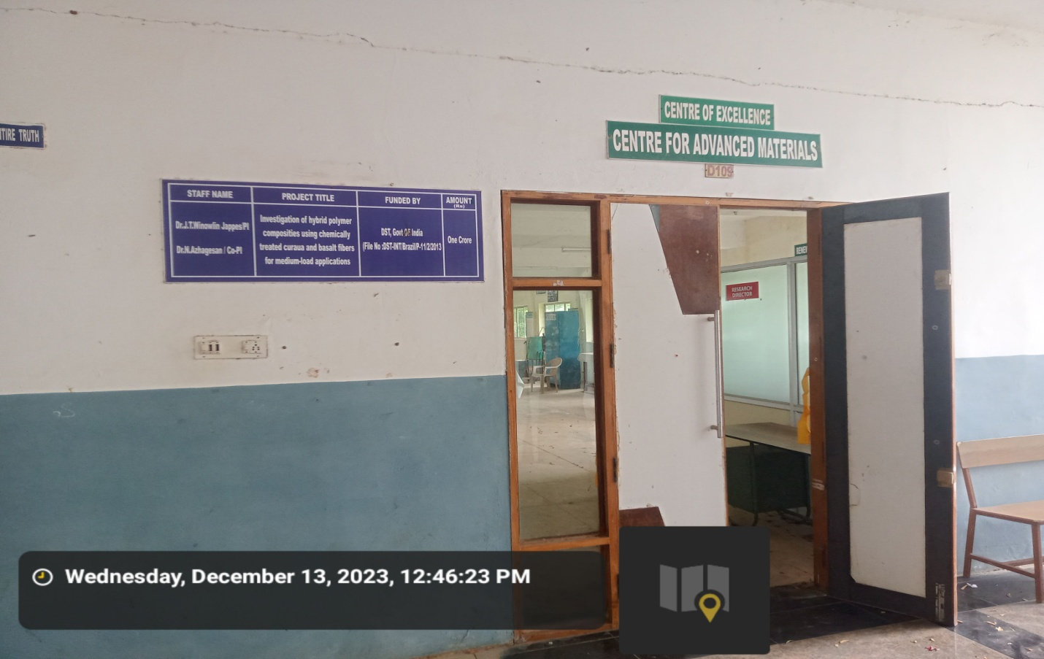



**CAMPUS MANAGEMENT SYSTEM**

